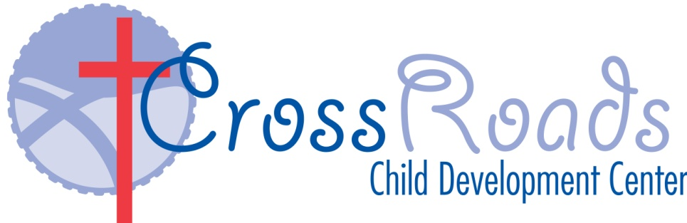

2023 - 2024 School Calendar
September March
4 Labor Day- CCDC CLOSED 28 Easter Celebration
29 Good Friday CCDC Closed

October April
1 Easter Monday CCDC Closed
27 CCDC CLOSED Professional Developmental Day
31 Halloween Celebrations

November May

3 Progress Reports
6-10 Parent/Teacher Conferences
13-17 Parent/Teacher Conferences 27 Memorial Day- CCDC CLOSED

23-24 Thanksgiving Break- CCDC CLOSED
December June

22-26 CCDC Closed Christmas Break 13 CrossRoads Crossover”/Pre K Graduation at 10:00
14 Teacher In-Service Day- CCDC CLOSED
27-28 CCDC Open at 8 am and Close at 3pm 19 Juneteenth CCDC Closed
29- Jan 2 CCDC Closed New Year’s Break 17 First Day of Summer Adventure

January July
2 CCDC CLOSED
15 MLK- CCDC CLOSED 3 4th of July Picnic & Parade 27 Progress Report 4 July 4th Holiday- CCDC CLOSED

February August
14 Valentine’s Day Celebration 26 Last Day of Summer Adventure

